**Abstract**

Traffic sign classification is an important topic in computer vision and autonomous cars. It is the process of recognising and classifying various sign images and grouping them according to their similarities. It consists of three phases namely, detection, classification, and tracking. This project focuses on using deep neural networks to classify traffic signs from the German Traffic Sign Recognition Benchmark (GTSRB) dataset. The models to be implemented will be evaluated using the confusion matrix and the accuracy score.

**Introduction**

Most road accidents are because of errors from the driver. The current electronic system implemented in cars to reduce road accidents is the advanced driver assistance systems (ADAS). It is used to assist drivers by automatically detecting traffic signs, recognising speed limits, detecting lane lines with the help of sensors and cameras installed in the car (Swathi and Suresh, 2017). However, this is not a simple process as some obstacles are encountered during data collection as shown in Fig. 1, such as object variations, lighting, speed, occlusions, limitation of the camera, and viewpoints (Madan, et al., 2019). Traffic sign classification involves recognising various sign images on the road and grouping them according to their respective classes or similarities. The goal of computer vision is to make artificial system see and interpret images just as humans. This is being achieved with the help of deep neural networks (DNN) and improved graphical processing units (GPUs). DNN have been used for image classification, object detection and speech recognition due to their high level of accuracy. However, due to the high performance of the convolutional neural networks (CNN) in the 2012 ImageNet competition (Deng, et al., 2012), it became the go-to algorithm for all image-related task such as image classification, recognition, localisation and identification (LeCun, Bengio and Hinton, 2015; Zhu, et al., 2016).

Before the emergence of deep learning algorithms such as the convolutional neural network (CNN), some traditional computer vision techniques like the histogram of gradients (HOG), colour and shape-based detection were used for identifying traffic signs (Tabernik and Skocaj, 2020).

The aim of this project is to build two CNN architecture based on the LeNet and VGGNet when trained with data augmentation as compared with hand augmented data to reduce the amount of time spent training and the computation power. To assess their performance, both models will be used to accurately classify traffic signs from the German traffic sign recognition benchmark (GTSRB) dataset.



Fig 1. Sample of images from the GTSRB dataset showing various vision-challenges associated with data gathering (Liu, Liu and Sun, 2014:p.76).

|  |  |  |  |  |  |  |  |
| --- | --- | --- | --- | --- | --- | --- | --- |
| Column One | Column Two | Column  Three | Column  Four | Column  Five | Column  Six | Column  Seven | Column  Eight |
| variance in the size of traffic signs | poor picture quality due to camera quality | blurred images | differences in the lighting condition | weather conditions such as dust and rain | objects or building behind the traffic sign | varied image rotation due to terrain or the position of the traffic sign | occlusion |

Table 1. Explanation of problems associated with traffic sign recognition dataset as shown in fig 1 above.

**Background**

Traffic sign recognition is made up of three phases and they are detection, classification, and tracking. The techniques for classifying traffic signs can be divided into i) handcrafted features ii) Learning-based method (state-of-the-art).

*Handcrafted image features*

As the name suggests, they are features created by professionals to extract certain attributes from an image as compared to the state-of-the-art method which automatically learns which features are to be extracted. An example is the edge detection algorithm which detects edges by looking out for a sharp change in the pixel values (intensity). These features are normally implemented and feed into traditional machine learning algorithms such as the Support Vector Machine (SVM). An example is the Histogram of oriented Gradients (HOG). The HOG is a feature descriptor proposed by Dalal and Triggs (2005) for the processing of images to detect objects. It removes irrelevant features from the image by calculating the horizontal and vertical gradients of the image through a kernel. The relevant features are extracted in a vector. This vector is then fed into a classification algorithm such as the support vector machine.



Fig 2. The workflow of feature extraction and object detection in HOG (Dalal and Triggs, 2005:p.887).

*State of the art method*

The process of training a CNN model for real-world applications is usually time-intensive and requires a good graphical processing unit. Girshick et al (2014) proposed a CNN architecture called faster region-based convolutional neural network (R-CNN) to overcome the object detection challenges associated with the bounding boxes of multiple regions of interest. It uses a selective search algorithm to extract 2000 region proposals from the images which in turn reduces the computational power used to train the network. However, this architecture uses about forty-seven seconds to scan each image in the bounding box, hence it cannot be used on real-time data. Jmour, Zayen and Abdelkrim (2018) proposed a model for classifying real-time coloured traffic sign images. This model reused parts of the training layer from a pre-trained model on the ImageNet dataset and then, the parameters were fine-tuned to meet the requirements. Although this model achieved an overall accuracy of 93%, it was only trained to recognise four categories of traffic signs which limits its performance. Zhu et al (2016) proposed a framework for traffic sign classification by combining a CNN with a trained fully convolutional network (FCN). The network draws a bounding box on the detected traffic sign and was evaluated on the Swedish Traffic Signs Dataset (STSD). The advantage of this network was that it had fewer false positives while reducing the time spent on training with a 93.27% precision value. Haloi (2015) proposed a model which combined multiple filters in one layer to reduce the number of training parameters. This achieved a high accuracy of 99.81% when applied on the GTSRB dataset. The drawback to this model was that it was not validated or cross-validated.

**Methods**

The dataset used is the German traffic sign recognition benchmark (GTSRB) dataset (Stallkamp, et al., 2012). It was released during the 2011 classification challenge during held at the International Joint Conference on Neural Networks (IJCNN) (Sermanet and LeCun, 2011). The dataset has more than 50,000 traffic sign images ranging from 15X15 to 222X193 pixels with 43 classes. To carry out this experiment, an input image of 1024 pixels (32x32) is used as the independent variable while the dependent variable is the predicted traffic sign.

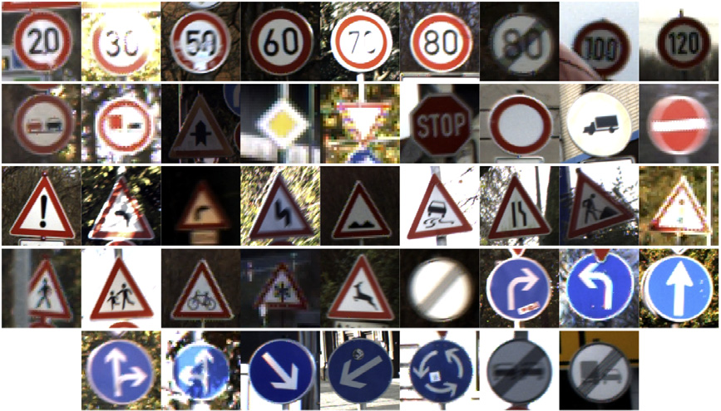

Fig 3. A random sample from the GTSRB dataset (Stallkamp, et al., 2012:p.325)

*Data Pre-processing*

The images will have to be pre-processed due to the variances in their shape, size, and quality. The first step would be to split the dataset into train, test, and validation set. Then each coloured image will be converted to grayscale and rescaled to 32 x 32 pixel. The final stage before training would be to normalise the images to reduce the computational time.

*CNN Architectures*

The LeNet architecture was designed to recognise the handwriting on cheques by Lecun et al (1998). It consists of seven layers which contains three convolutional layers, two subsampling layers and two fully connected layers.

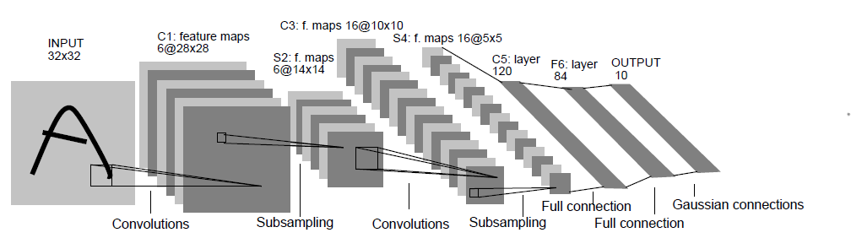

Fig 4. Structure of the LeNet architecture (Lecun, et al., 1998:p.7)

The first layer serves as the input which takes in a 32X32 grayscale image. This image is taken through the first convolutional layer (C1) having 6 feature maps. Each feature map has a 5x5 filter with a stride of one. This reduces the image dimension to 28x28 pixels. Next is the average pooling or sub-sampling layer (S2). It has a filter size of 2x2 and two strides which further reduces the image dimension from 28x28 to 14x14 pixels. The third layer is the second convolutional layer (C3) which has 16 feature maps of size 5x5 with one stride. Only 10 feature maps are connected to the 6 feature maps in the previous subsampling layer. This is done so that different features are extracted from the input.

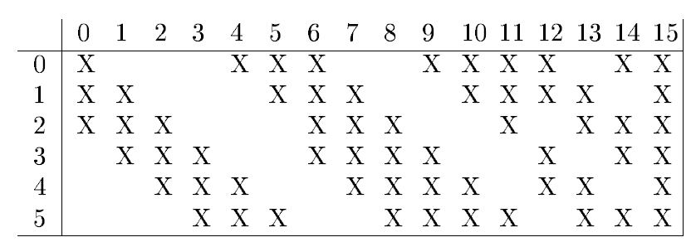

Fig 5. Figure showing the 10 feature maps connected to S2 from C3 (Lecun, et al., 1998:p.8)

The fourth layer is the second subsampling layer (S4) which has 16 feature maps of size 5x5 with a 2x2 filter size. The third convolutional layer (C5) is the fifth layer. It has a total of 120 feature maps. Each map is connected to the feature map in S4. The sixth layer (F6) is fully connected to the third convolutional layer (C5). The output layer is the second fully connected layer.

VGGNet was developed by Simonyan and Zisserman (2014). It has 19 hidden layers with 138 million parameters.

*Resources*:

Due to the computational requirements, this experiment will be conducted using Google Colab. It is an online Jupyter notebook environment provided by Google.

Hardware: 1xTesla K80 GPU, 12GB GDDR5 VRAM.

**References**

1. Dalal, N. & Triggs, B. (2005) Histograms of oriented gradients for human detection. In *2005 IEEE computer society conference on computer vision and pattern recognition (CVPR'05)*, San Diego, CA, USA, IEEE. 1, pp.886-893. Available from: doi: 10.1109/CVPR.2005.177.‌
2. Deng, J., Berg, A., Satheesh, S., Su, H., Khosla, A. & Fei-Fei, L. (2012) Imagenet large scale visual recognition competition 2012 (ILSVRC2012).  p.41. Available from: http://www.image-net.org/challenges/LSVRC/2012.
3. Girshick, R., Donahue, J., Darrell, T. & Malik, J. (2014) Rich feature hierarchies for accurate object detection and semantic segmentation. In *Proceedings of the IEEE conference on computer vision and pattern recognition,* Columbus, OH. pp.580-587. Available from: doi:10.1109/CVPR.2014.81.‌
4. Haloi, M. (2015) Traffic sign classification using deep inception based convolutional networks. *arXiv preprint arXiv:1511.02992*.
5. Jmour, N., Zayen, S. & Abdelkrim, A. (2018) Convolutional neural networks for image classification. *2018 International Conference on Advanced Systems and Electric Technologies (IC_ASET)*. pp.397-402.
6. LeCun, Y., Bengio, Y. & Hinton, G. (2015) Deep learning. *Nature*. 521(7553), pp.436–444.
7. Lecun, Y., Bottou, L., Bengio, Y. & Haffner, P. (1998) Gradient-based learning applied to document recognition. *Proceedings of the IEEE*, 86(11), pp.2278–2324. Available from: doi: 10.1109/5.726791.
8. Liu, H., Liu, Y. & Sun, F. (2014) Traffic sign recognition using group sparse coding. *Information Sciences*, 266, pp.75–89.
9. Ioffe, S. and Szegedy, C. (2015) Batch normalization: Accelerating deep network training by reducing internal covariate shift. *arXiv preprint arXiv:1502.03167*.
10. Madan, R., Agrawal, D., Kowshik, S., Maheshwari, H., Agarwal, S. & Chakravarty, D. (2019) Traffic Sign Classification using Hybrid HOG-SURF Features and Convolutional Neural Networks. *ICPRAM*. pp.613-620.
11. Simonyan, K. and Zisserman, A. (2014) Very deep convolutional networks for large-scale image recognition.
12. Sermanet, P. & LeCun, Y. (2011) Traffic sign recognition with multi-scale convolutional networks. In *The 2011 International Joint Conference on Neural Networks*, San Jose, CA, IEEE. pp.2809-2813. Available from: 10.1109/IJCNN.2011.6033589.
13. Swathi, M. & Suresh, K.V. (2017) Automatic traffic sign detection and recognition: A review. *International Conference on Algorithms, Methodology, Models and Applications in Emerging*
14. *Technologies (ICAMMAET).* pp.1-6. Available from: doi:10.1109/icammaet.2017.8186650
15. ‌Stallkamp, J., Schlipsing, M., Salmen, J. & Igel, C. (2012) Man vs. computer: Benchmarking machine learning algorithms for traffic sign recognition. *Neural Networks*. 32, pp.323-332.
16. Tabernik, D. & Skocaj, D. (2020) Deep Learning for Large-Scale Traffic-Sign Detection and Recognition. *IEEE Transactions on Intelligent Transportation Systems*. 21(4), pp.1427–1440.
17. Zhu, Y., Zhang, C., Zhou, D., Wang, X., Bai, X. & Liu, W. (2016) Traffic sign detection and recognition using fully convolutional network guided proposals. *Neurocomputing*, [online] 214, pp.758–766.
18. Zhu, Z., Liang, D., Zhang, S., Huang, X., Li, B. & Hu, S. (2016) Traffic-sign detection and classification in the wild. In *2016 IEEE Conference on Computer Vision and Pattern Recognition (CVPR)*, Las Vegas, NV, IEEE. pp.2110-2118.